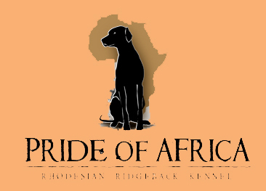
B litter - Pride of Africa kennel
"GUCCI"  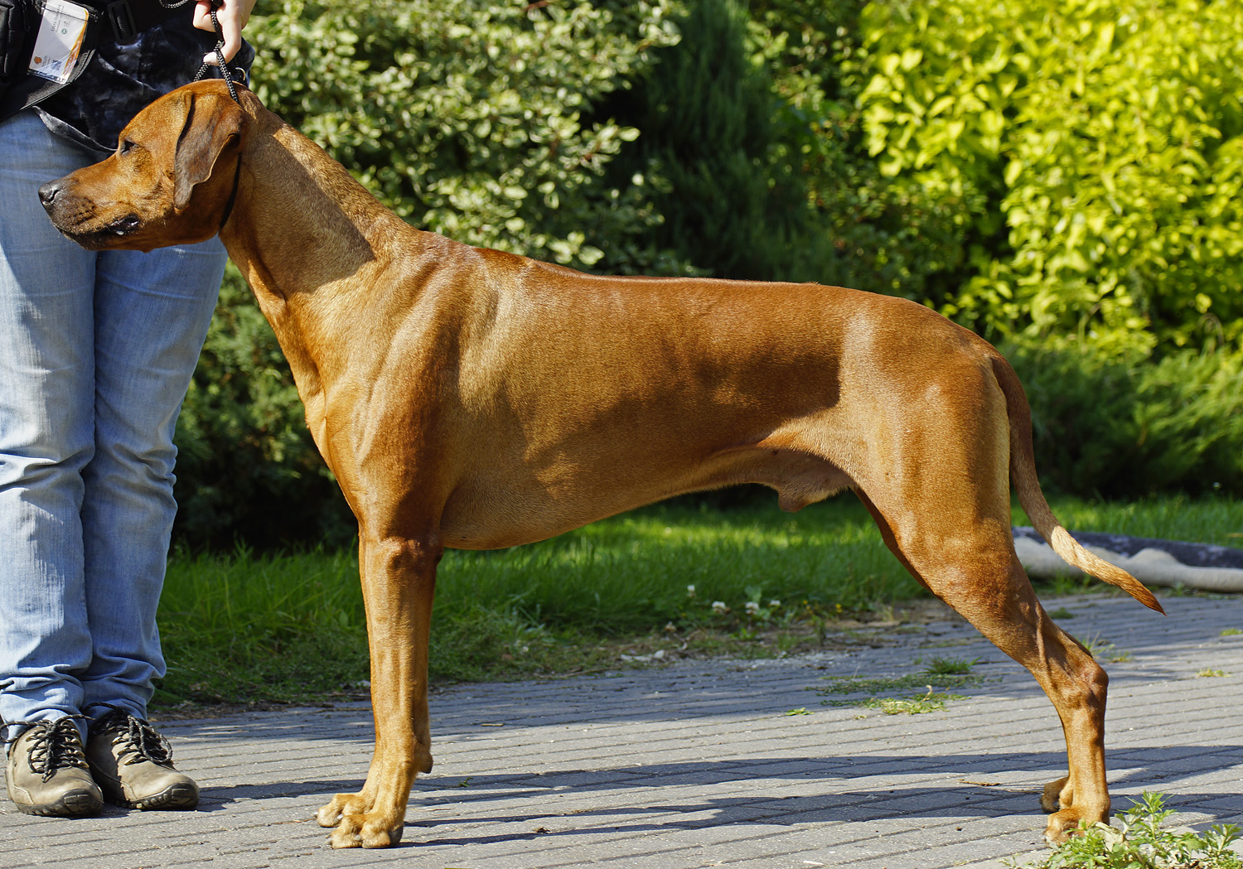  Champion  Wytrawny Gucci Sangoma  (USA/Australia)  HD A/A, ED 0/0  OCD neg., LTV neg.  EOAD clear, DM N/N  Rr  full dentition  67 cm | 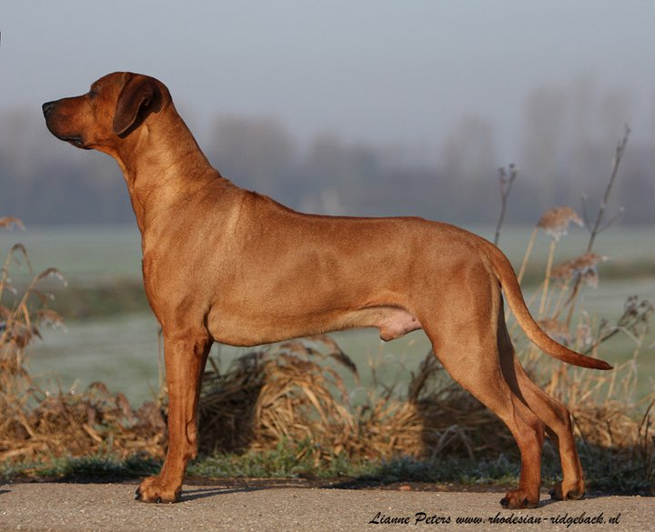  Champion  Thokoza Ngumo  HD A, ED 0/0  OCD free  Blue dillute DD (free)  DM N/N  full dentition  68 cm | 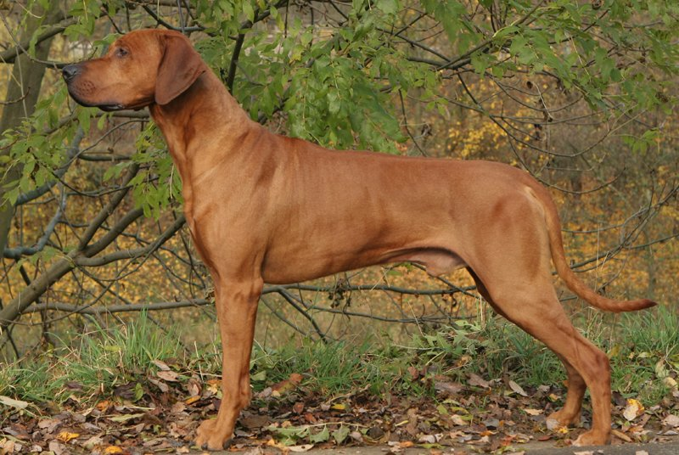  Ikimba Zesiro  HD A, ED/OCD free | Champion  Ikimba Tumomak Sheikh  HD good ED clear | Champion  Rijstone Diesel N Dust
Champion
Aslan's Dolly of Ikimba
 |  |  | Ikimba Ushanga  HD A/A, ED 0/0 | Gr.Champion  Caprivi Cool Hand Luke ANKC
Champion
Ikimba Rolanda
 |  | 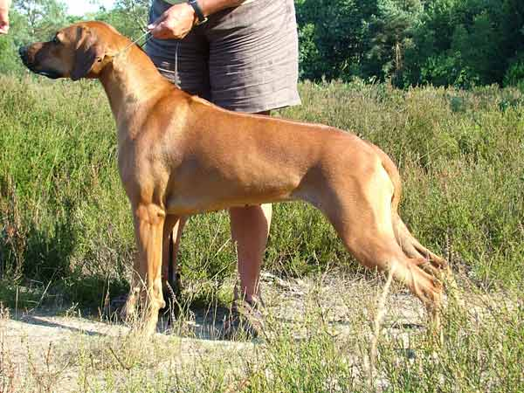  Champion  Thokoza Ziezonogo  HD-A, ED/OCD free | Thokoza Azibo  HD-A | Chywanja Arik
Champion
Thokoza
 |  |  | Champion  Kimani's Image For Thokoza  (imp. Am.)  HD TC | Champion  Kimani's The Standard Image
Champion
Kimani's Calico Ridge Jetset
 | 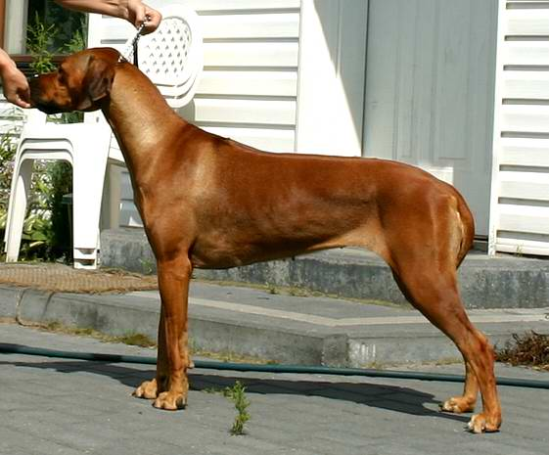  Champion  Sangoma Tajemnica Tkwi W Ogonku  HD A/A, ED 0/0  OCD free  thyroid in normal  full dentition  62 cm  gen for brown nose | 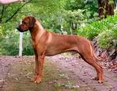  Aus & NZ Champion  Rhodepark Red Dragon | 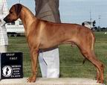  BIS BISS Am & Aust Champion  Camelot's Code Red | Champion  Kimani's Blue Chip Image
Champion
Camelot's Follow the Sun
 |  |  | Aust Champion  Rhodepark Mi Illusion E.T | Champion  Isilwane Frequent Flyer
Champion
Kenricky Maddys Girl
 |  | 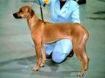  Harjaselän Ijumaa Imani | 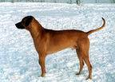  Rex Ventors Corregidor | Champion  Bearstar Ko
Champion
Ökensandens Savannah of Djungelkatten
 |  |  | 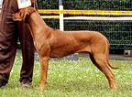  Int Ch, Fin, Est, Rus, Ltu, Lv & Blr Ch, Baltic Ch, EUW-99, EstW-99, BaltW-98  Ikimba Marimba | IC  Mashaba's Harubah
Champion
Shadyridge Penda of Ikimba
"PHOEBE"  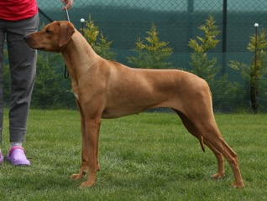  MultiCh.  Dream Phoebe Manwë (Australia/USA/SAf)  HD A/A, ED 0/0  OCD neg., LTV neg.  EOAD clear, DM N/N  D-lokus D/D  B-lokus B/b  thyroid in normal  juvenile ME clear  full dentition  64,5 cm  gen for brown nose |  |  |  | Champion  Besal Golden Rule  gen for brown nose
  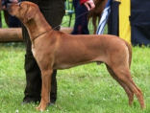
  Adam Abeo Magmabona
  (Saf/USA/EU)
  HD 0/0, ED 0/0, OCD free
  DM free, blue dilute D/D
  full dentition
  thyroid in normal
  mental tested
  gun shoot proof
  ZOP, ZZO
  67,5 cm
  gen for brown nose
  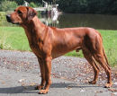
  Ich.MultiCh.,BISS
  Rachral Abayomi Hintza
  HD, ED, OCD free
  full dentition
  67 cm
  gen for brown nose
  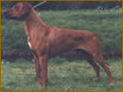
  Champion
  Mswanti´s Mwanamoetapa
  HD-A
  full dentition
  68 cm
  gen for brown nose
Champion
Jockular Jinja
 |  |  |  | Champion  Sarula Debuka
  Jockular Rachral a Thamani
  HD-A
  full dentition
  64 cm
Champion
Jockular Kundalina
 |  |  |  | USA, IT Champion  Rhodys Pride Mufasa Leoridge
  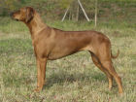
  Champion
  Aliss Brassila Zulaykha
  HD, ED, OCD free
  full dentition
  64 cm
  gen for brown nose
  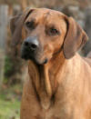
  Champion, BISS
  Leoridge Musafah
  HD, ED, OCD, LTV free
  full dentition
  69,5 cm
  gen for brown nose
USA, IT Champion
Rouxridge Nala of Leoridge
brown nose
 |  |  |  | Champion  Angel od Křemence
  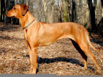
  Ella Saranga
  HD-A
  full dentition
  62 cm
Champion
Bendy z Vrboveckého mlýna
 |  | 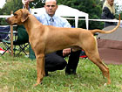  MultiCh.  Stenänga Great G'S Chili  (imp.Sweden)  HD A/A, ED 0/0, OCD free  full dentition  70 cm  gen for brown nose |  | USA Ch.  Springvly Spence O'Laurlcrest
  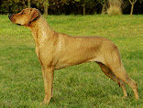
  MultiCh.
  Tusani Extra Spice
  (Australia x USA/Sweden)
  HD A/A, ED 0/0
  thyroid in normal
  full dentition
  mental tested
  gun shoot proof
  63,5 cm
  gen for brown nose
  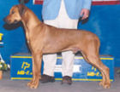
  BIS, BISS, USACh.
  Spring Valley's
  Great Gatsby ROM
  HD, ED free,
  full dentition,
  heart CERF
  gen for brown nose
USA Ch.
Spring Valley's Pee Dee
 |  |  | Nord Ch.  Madahiro´s Good Enough  HD, ED free,  TT - temperament tested,  full dentition | MultiCh.  Aakemba King Astor Gi´Fumo
 |  |  |  | Madahiro´s R´Zafaco Millie
 |  | 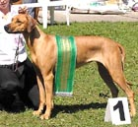  Multi BISS, ICH, Multi Ch.  Macumazahn  Tusani Pearl  (imp. Australia)  HD A/A, ED 0/0, OCD neg  Full set of teeth |  | BIS/BISS Aust.Ch.  Caprivi Inside Edge
  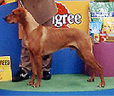
  MultiBIS,
  Aust.GrandCh.
  Ozrhode
  Ari Mystic Fate
  (Australia)
  HD, ED free,
  full dentition
BISS, Aust.Ch.
Ozrhode Midas Touch
 |  |  |  | Aust.Ch.  Rijstone Diesel N´Dust
  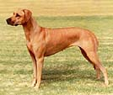
  MultiBISS, Aust.Ch.
  Macumazahn Pearl Jam "Spice"
  (Australia)
  HD, ED free,
  full dentition
Champion
Macumazahn Class Action

