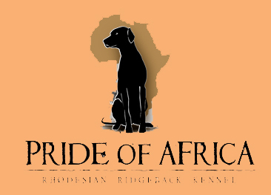
C litter - Pride of Africa kennel
"ART"  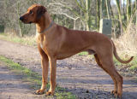  C.I.B., GrandCh., MultiCh., ClubCh.  Artaban Cieply Dom (USA/CAN/Norway/Australia)  HD A/A, ED 0/0  OCD neg., LTV neg.  EOAD clear, DM N/N  D-lokus D/D  B-lokus B/B  thyroid in normal  JME clear, SA neg.  full dentition  68 cm | 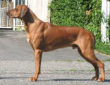  BISS, BPISS, CAN Ch.  The Black Pearl of Course  HD, ED free  69 cm, full dentition | 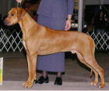  USA Ch.  Paradigm Total Chaos Reigns, JC  HD, ED free, CERF free | 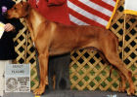  Champion  Ridgelea’s Shakar Viken  HD, ED free | 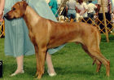  Champion  Crosswick Time Loves a Hero
Champion
Ridgelea Saber Sharpest Edge
 |  |  | 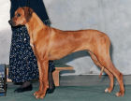  Champion  Sienna’s Roxanne of Paradigm  HD, ED free, CERF free | Champion  Kimani’s Sharper Image ROM
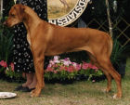
Champion
Sienna’s Seminole Wind
JC, ROM
brown nose
 |  | CAN Ch.  Grandby Red Jade of Course  HD, ED free | Champion  Kopera’s Gusto of Course | Rajataru El Toro
 |  |  |  | Wheatenridge’s Challenger
 |  | CAN Ch.  Grandby Red Jade of Course  HD, ED free | 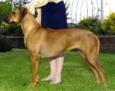  Grandby Jakkals Mafaro | Rainbow’s Bosveldt Jakkals
 |  |  |  | Hottentots Langpoot Penelope
 | 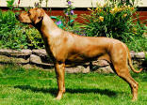  Champion  Maendeleo A-Team Angel Dreamgirl  HD, ED, OCD free  63 cm, full dentition | 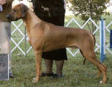  USA Ch.  Nashira’s Zinfully Good Juba Lee  HD, ED, OCD free, full dentition | 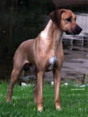  USA Ch.  Juba Lee’s What About Bob  HD, ED free, full dentition | 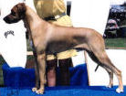  USA Ch.  Oakhurst Kukosa Dreyfus  HD-A
USA Ch.
Juba Lee Esprite of Oakhurst
HD-A
 |  |  | USA Ch.  Nashira’s Private Collection  HD, ED free, full dentition | Champion  Springvalley’s Merlin Of Nashira, JC  HD, ED free  brown nose
USA Ch.
Damietta Of Nashira
HD, ED free
 |  | 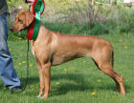  Nordic, SU Ch.  Kangelani’s Gentle Grace by Clay  HD, ED free  gen for brown nose | 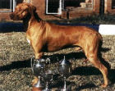  SAF, ZIM Ch.  Globe’s Roving Red Regent  HD, ED free  brown nose | USA Ch.  Royalton’s Blue Max  HD, ED free
USA Ch.
Globe’s Calia Toi Soldier
HD, ED free
 |  |  | 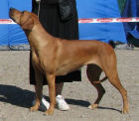  ICh., NordicCh.  Kamba Anatulinda’s E’Zena  HD, ED free | 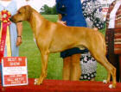  Ich., USA, CAN Ch.  Wetu Of Kalahari  HD, ED free
Ich., Nordic Ch.
Sixemm Kissrdby Anangel (imp. AUS)
HD, ED free
"PHOEBE"  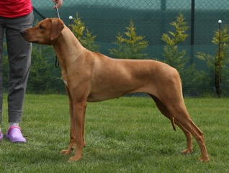  MultiCh.  Dream Phoebe Manwë (Australia/USA/SAF)  HD A/A, ED 0/0  OCD neg., LTV neg.  EOAD clear, DM N/N  D-lokus D/D  B-lokus B/b  thyroid in normal  JME clear  full dentition  64,5 cm  gen for brown nose |  |  |  | Champion  Besal Golden Rule  gen for brown nose
  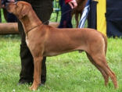
  Adam Abeo Magmabona
  (Saf/USA/EU)
  HD 0/0, ED 0/0, OCD free
  DM free, blue dilute D/D
  full dentition
  thyroid in normal
  mental tested
  gun shoot proof
  ZOP, ZZO
  67,5 cm
  gen for brown nose
  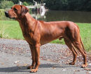
  Ich.MultiCh.,BISS
  Rachral Abayomi Hintza
  HD, ED, OCD free
  full dentition
  67 cm
  gen for brown nose
  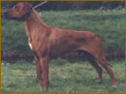
  Champion
  Mswanti´s Mwanamoetapa
  HD-A
  full dentition
  68 cm
  gen for brown nose
Champion
Jockular Jinja
 |  |  |  | Champion  Sarula Debuka
  Jockular Rachral a Thamani
  HD-A
  full dentition
  64 cm
Champion
Jockular Kundalina
 |  |  |  | USA, IT Champion  Rhodys Pride Mufasa Leoridge
  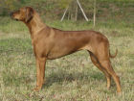
  Champion
  Aliss Brassila Zulaykha
  HD, ED, OCD free
  full dentition
  64 cm
  gen for brown nose
  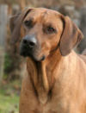
  Champion, BISS
  Leoridge Musafah
  HD, ED, OCD, LTV free
  full dentition
  69,5 cm
  gen for brown nose
USA, IT Champion
Rouxridge Nala of Leoridge
brown nose
 |  |  |  | Champion  Angel od Křemence
  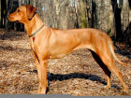
  Ella Saranga
  HD-A
  full dentition
  62 cm
Champion
Bendy z Vrboveckého mlýna
 |  | 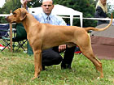  MultiCh.  Stenänga Great G'S Chili  (imp.Sweden)  HD A/A, ED 0/0, OCD free  full dentition  70 cm  gen for brown nose |  | USA Ch.  Springvly Spence O'Laurlcrest
  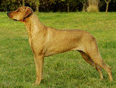
  MultiCh.
  Tusani Extra Spice
  (Australia x USA/Sweden)
  HD A/A, ED 0/0
  thyroid in normal
  full dentition
  mental tested
  gun shoot proof
  63,5 cm
  gen for brown nose
  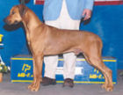
  BIS, BISS, USACh.
  Spring Valley's
  Great Gatsby ROM
  HD, ED free,
  full dentition,
  heart CERF
  gen for brown nose
USA Ch.
Spring Valley's Pee Dee
 |  |  | Nord Ch.  Madahiro´s Good Enough  HD, ED free,  TT - temperament tested,  full dentition | MultiCh.  Aakemba King Astor Gi´Fumo
 |  |  |  | Madahiro´s R´Zafaco Millie
 |  | 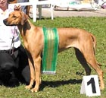  Multi BISS, ICH, Multi Ch.  Macumazahn  Tusani Pearl  (imp. Australia)  HD A/A, ED 0/0, OCD neg  Full set of teeth |  | BIS/BISS Aust.Ch.  Caprivi Inside Edge
  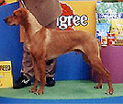
  MultiBIS,
  Aust.GrandCh.
  Ozrhode
  Ari Mystic Fate
  (Australia)
  HD, ED free,
  full dentition
BISS, Aust.Ch.
Ozrhode Midas Touch
 |  |  |  | Aust.Ch.  Rijstone Diesel N´Dust
  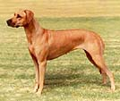
  MultiBISS, Aust.Ch.
  Macumazahn Pearl Jam "Spice"
  (Australia)
  HD, ED free,
  full dentition
Champion
Macumazahn Class Action

